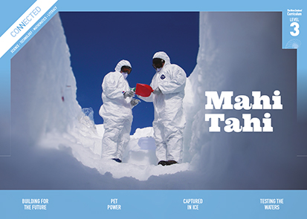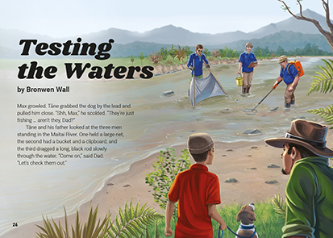
Connected
Level 3
2017

Testing the Waters
by Bronwen Wall

Overview
This article describes how scientists are testing the health of Maitai River. It looks at how the information they gather is used to make the river safer for the creatures that live in and near the river, including people and their pets. This article uses a combination of text forms, including narrative.
A Google Slides version of this article is available at www.connected.tki.org.nz

Curriculum contexts

SCIENCE: Nature of Science: Participating and contributing  Level 3 – Students will explore various aspects of an issue and make decisions about possible actions. | Key Nature of Science ideas  When we engage scientifically with an issue, we:  - Look for a range of scientific information that relates to the issue  - Check that information we use is from a trustworthy source  - Consider the reliability and validity of the evidence  - Decide if and how to respond to the issue, justifying our decisions based on evidence and/or reliable scientific information  - Monitor the effects of any actions we take.
SCIENCE: Living World: Ecology  Level 3 – Students will explain how living things are suited to their particular habitat and how they respond to environmental changes, both natural and human-induced. | Key science ideas  - Living things depend on the non-living environment in which they live.  - Every waterway has a range of habitats where different kinds of living things can be found.  - Changes in the environment may affect the survival of some species.  - People can cause changes to habitats from which recovery may be difficult. People can also intervene to aid that recovery.
ENGLISH: Reading  Level 3 – Ideas: Students will show a developing understanding of ideas within, across, and beyond texts. | Indicators  - Uses their personal experience and world and literacy knowledge confidently to make meaning from texts.  - Makes meaning of increasingly complex texts by identifying main and subsidiary ideas in them.  - Starts to make connections by thinking about underlying ideas in and between texts.  - Makes and supports inferences from texts with increasing independence.
MATHEMATICS and STATISTICS: Statistics: Statistical literacy  Level 3 – Students will evaluate the effectiveness of different displays in representing the findings of a statistical investigation or probability activity undertaken by others. | Key mathematics ideas  - Data can sometimes be used to help predict a future event.  - Organising data can reveal information, patterns, and trends.  - Looking for patterns is an important part of statistical thinking.

The New Zealand Curriculum

Science capability: engage with science

Capability overview
This capability requires students to use the other capabilities to engage with science in real-life contexts. It requires students to take an interest in science issues, participate in discussions about science, and at times, take action.  The dimensions of this capability can be demonstrated when students engage in discussions about science issues, including those in the media. If these discussions build on the ideas of others, emphasise logical connections, and draw reasonable conclusions, and if the speakers make the evidence behind their claims explicit, then students have the opportunity to practise playing the “game of science” (Resnick, Michaels, & O’Connor, 2010). | This allows them to deepen their understanding of what science is.  Students also need opportunities to be actively engaged in exploring real-life science issues that are relevant to them and their communities. This could involve building new knowledge with others and taking action to address local or global concerns.

More about the capability

The capability in action
Real-life science issues:  - may involve a mix of scientific issues and forms of social-science inquiry, including values and ethics  - provide opportunities to build awareness of which questions can be investigated and which questions science does not answer  - provide opportunities to see science as tentative, that is, developing over time as evidence is gathered or reinterpreted  - provide experiences of uncertainty where there is no clear explanation or solution  - allow students to gather and interpret data about a local situation or to critique a range of evidence and claims  - may generate a range of student views, responses, and possible actions.  Students  Students should have opportunities to:  - take an interest in a range of scientific issues  - participate in discussions about scientific issues  - use their developing capabilities of gathering and interpreting data, using and critiquing evidence, and interpreting representations to create a viewpoint, response, or action on scientific issues.  Teachers can:  - establish a science classroom culture by:  - taking a personal interest in scientific issues, modelling questions, explicitly critiquing evidence, and seeking further evidence  - maximising everyday opportunities to introduce learning conversations that engage students with science and scientific issues | - helping their students to notice and investigate science in their everyday surroundings, such as ice on a puddle, the health of a local stream or river, or what happens as materials are mixed or heated  - listening to and discussing socio-scientific items in the news  - exploring locally relevant and contentious scientific issues, such as irrigation, intensive farming, or the effects of climate change  - support students to identify scientific aspects of an issue  - provide a range of resources and investigation opportunities pertaining to scientific issues that require students to use a range of science capabilities  - encourage students to seek and critically evaluate a range of scientific evidence, opinions, and actions from a variety of sources about an issue  - manage with sensitivity situations where students and their whānau may hold differing and strongly held opinions about a science-related issue, such as irrigation  - support students to identify and take appropriate actions in response to science-related issues.  It is important that students are empowered to be hopeful and see opportunities for positive action and change when considering local and global issues.

More activities to develop the capability

Meeting the literacy challenges

The main literacy demands of this text are the mixture of narrative text and breakouts. The breakouts include:  - an infographic showing the species found in tributary stream  - a graph of the species living in the river  - an infographic showing the contribution of urban and rural runoff to the development of algae  - a map showing the location of the river in relation to Nelson city.  Students will need to integrate information from the narrative text, the breakouts, and the visual features in order to fully understand the science ideas and information. | The text contains some unfamiliar vocabulary particularly in relation to creatures living in the river and scientific and environmental processes and their impact. A glossary supports vocabulary not explained or described in the text.  The following instructional strategies will support students to understand, respond to, and think critically about the information and ideas.  You may wish to use shared or guided reading, or a mixture of both, depending on your students’ reading expertise and background knowledge.  After reading the text, support students to explore the activities outlined in the following pages.

INSTRUCTIONAL STRATEGIES

Finding the main ideas  Have the students read the title and the text on page 26. PROMPT them to ASK QUESTIONS about what the article is about and the way the information is conveyed.  I wonder what this article is about. What makes Max, Tāne, and Dad think something “fishy” is going on? What do you suppose the three men are doing? Are there clues in the pictures?  I thought all the articles in Connected were about science. This feels like a story. Doesn’t that mean it isn’t real? Can I trust the information? Is this a good way of teaching people about science?  ASK the students to SCAN the text to notice the range of text types. LIST the different ways the author and illustrator convey information.  Is this article fiction or non-fiction? How can you tell? Why do you think the author included a narrative? Why are there these other text types? What do you think about the pictures and the diagrams? This is an unusual way to learn about science. Is it effective? Think about this as you read, and we’ll discuss it when we finish.  PROMPT the students to make inferences about how a previously polluted river could have ended up winning the second-most-improved-river award.  What information would have been used to decide the award? How did you work that out?  What does “mahitahi” mean? What does that suggest about the way the different groups improved the river? What might each of the groups have contributed to the mahi: the community groups, scientists, and local iwi?  PROMPT the students to notice Tāne’s use of inference:  - What information did Tāne use to work out that the young trees would have been planted to prevent algae growth?  - How did he confirm his inference?  - How do we use inference as readers?  - Do you think scientists also make inferences? How would they do that? | DISCUSS Mike’s comment that “Anything that changes the environment can be bad.”  What are some examples of changes to the environment that have been bad?  Are all changes to the environment bad? What are some examples of good changes to the environment?  After the reading, look again at the list of text forms and visual features you created when scanning the text. Ask the students to identify the purpose of each, recording it on a table like the one below. DISCUSS the different forms. Ask students whether they find this combination of text types effective. Have the students record and explain their personal opinion at the bottom of the table.  Text form Purpose  Is this an effective way of communicating about science? Why? Why not?  Using design features for deeper understanding  PROMPT the students to look closely at the two ways data is presented on pages 28–29. ASK QUESTIONS to check that they understand how to read the data.  What does the infographic on page 28 show? How do you read it?  What is the most common species found in the York Stream?  What does the graph on page 29 tell us about the Maitai River? How do you read it?  Which year was the river in the best condition? What was the water quality like in 2010?  What do you think might have happened in 2014?

Meeting the literacy challenges

PROMPT the students to COMPARE the two ways that the data is presented and to recall and use the language of statistics.  In scientific investigations, the focus is often on one variable (factor that can be controlled or changed) and scientists try to keep the other factors the same. What is the changing variable in the infographic? What is the variable in the graph?  Apart from the variable they are studying, scientists need to try and keep other factors the same. What aspects are kept the same in the infographic? What aspects are kept the same in the graph?  “Scale” is a standard of measurement. How is scale shown in the infographic? How is it shown on the graph? Why is there this difference?  How does the type of data affect how it’s presented? Can you think of other ways that might have been effective?  PROMPT the students to ASK QUESTIONS about the data in the graph. Suggest some possible questions, then have the students work in pairs to make up their own questions for another pair to answer. Questions might include:  What do you think causes the dips?  Were the measurements taken at the same time each year?  Do you think the river is getting cleaner? Why? Why not?  Why do you think the MCI score goes up and down in different years? | PROMPT the students to look closely at the diagram on page 31. Ask them to follow one of the ways the water goes from rain to the sea.  What are some of the things the rain could wash into the river as it goes through different places?  Extending the learning  Repeat the tracking activity with the diagram about stormwater in the Connected article “Down the Drain” (level 2, 2017). Use these two activities as a springboard into inquiry about water quality, something that is currently a hot topic in New Zealand and around the world.  What does this add to your understanding about human impacts on the quality of water in the ecosystem?  What did you know already? Where did you learn this?  What do you think people should do about this?

Reading standard: by the end of year 6
The Literacy Learning Progressions
Effective Literacy Practice: years 5–8

Meeting the literacy challenges

TEACHER SUPPORT
Changes in the environment may affect the survival of some species. | Organising data can reveal information, patterns, and trends.  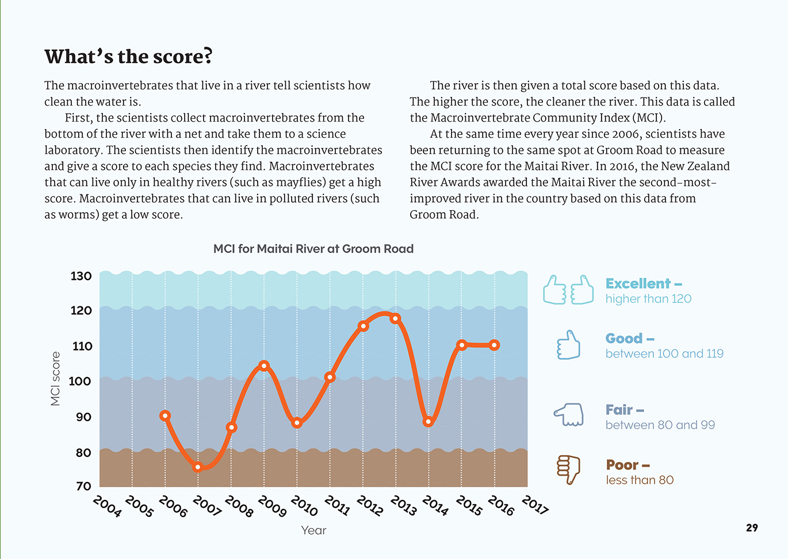
Looking for patterns is an important part of statistical thinking. | Scientists gather reliable evidence over time.

Learning activities – Exploring the science,
mathematics and statistics
The following activities and suggestions are designed as a guide for supporting students to explore and develop understandings about the science capability “engage with science”. Some activities focus directly on the science capability. Other activities extend student content knowledge across the learning areas. Adapt these activities to support your students’ learning needs.

Activity 1 – Gathering data to take action on water quality  Prompt the students to unpack the word “macroinvertebrate”. What does each part of this word mean? Have them investigate further examples of macroinvertebrates that can live in healthy rivers and those that can live in polluted rivers.  Have the students go to LAWA: Land Air Water Aotearoa’s website to read more about the Macroinvertebrate Community Index (MCI). Share the fact sheet on “Benthic macroinvertebrates”, which explains how sampling is done.  What do we need to do before we do any water sampling? (for example, wash hands before and after collecting samples; use a clean bottle for collecting a sample; label the bottle before collecting a sample.)  Encourage the students to explore LAWA’s website to find out how water quality is being measured in your local area, what the findings are, and what actions that are being taken.  What role does the MCI play in the work being done in our area? How else do people measure water quality?  Who is doing this work? Why? What questions are they looking at? What are they finding out? Are they making a difference?  How could we organise the information?  Prompt the students to reflect on what they have learnt.  - What have we learnt? What are the main issues in our area?  What else would you like to know about water quality? Who could we talk to about this?  Have the students read the article “How Do You Test Water Quality?”. This describes how young people in Alexandra are testing water quality in their local rivers.  What questions are they exploring?  How are they going about it?  How do you think they measure conductivity?  What has surprised them, and how has this led to a new focus for their investigation?  Ask the students if they would like to investigate the health of a waterway in your local area. Return to the LAWA site and ask students to identify an area of interest. This might include:  surveying the types of macroinvertebrates in a local waterway and researching the kind of water those macroinvertebrates can live in  using other water sampling techniques that they have read about  investigating a pollution issue  researching how people’s relationships with the waterway have changed over time  presenting their findings to the local council. | As indicated in the resource links, it would be a good idea to contact your regional council for assistance. Ideally, you will work with the groups that are already involved in this work. This will have reciprocal benefits for both the students and for those groups.  Extending the learning  Consider doing this in collaboration with other schools so that you can be more strategic in your investigation. This could mean covering a larger area over many years. This approach could also make it easier for local community groups, iwi, and authorities to work with the schools without stretching their resources. Students and teachers in different schools could compare their experiences, data, and actions.  Activity 2 – Learning about water catchment  Have the students look at photos of different landscapes. Using what they have learned from the article, have them talk about where the water would travel before it reaches the sea and what it could carry with it.  Take the students outside to look at the way the rainwater that falls on the school roof is managed:  Where does the down pipe empty into?  Where does the water from the playgrounds, gutters, and drains go to?  What could it carry into the streams rivers and sea?  What could we do to make sure it stays as clean as possible?  Have the students look at house and section plans that show stormwater drains. Working in groups, have them follow the path of rainwater and then suggest their own questions for a class discussion.  Have the students construct a model of the local catchment. Have them use this to persuade an audience that we are all responsible for looking after the quality of our local waterways.

Learning activities – Exploring the science, mathematics and statistics

Activity 3 – Making connections
There are clear connections to be made between the learning between this article and others in the Connected and School Journal series. Consider the following examples:
- In “The Fish Highway” (Connected 2013, level 3), a scientist gathers data about the fish and eels that use Wellington’s stormwater system to travel between streams and the sea.
- In “Counting Kākahi” (Connected 2014, level 3), a scientist investigates kākahi in the Whanganui River to find out whether the claims by local kaumātua that they are disappearing are true.
- In “Operation Duck Pond” (Connected 2015, level 2), we learn about ecosystems as a scientist looks at what makes a pond a good breeding habitat for ducks.
- In “Kaitiaki of the Stream” (School Journal October 2013, level 2,) Pātaka Moore of Te Wānanga-o-Raukawa in Ōtaki explains the history and significance of the Mangapōuri Stream. He also discusses how the stream, which is now unhealthy, might be restored.
The activities in the teacher support materials for these items include investigations and suggestions about how students could take action as citizen scientists.

RESOURCE LINKS

Building Science Concepts  Book 21, Life between the Tides: Sandy Shores, Mudflats, and Rocky Shores  Connected and School Journal  “The Fish Highway”, Connected 2013, level 3, Food for Thought http://instructionalseries.tki.org.nz/Instructional-Series/Connected/Connected-2013-level-3-Food-for-Thought/The-Fish-Highway  “Counting Kākahi”, Connected 2014, level 3, Why Is That? http://instructionalseries.tki.org.nz/Instructional-Series/Connected/Connected-2014-level-3-Why-Is-That/Counting-Kakahi  “Operation Duck Pond”, Connected 2015, level 2, Have You Checked? http://instructionalseries.tki.org.nz/Instructional-Series/Connected/Connected-2015-Level-2-Have-You-Checked/Operation-Duck-Pond  “Kaitiaki of the Stream”, School Journal October 2013, level 2 http://instructionalseries.tki.org.nz/Instructional-Series/School-Journal/School-Journal-Level-2-October-2013/Kaitiaki-of-the-Stream | Science Learning Hub  River ecosystems: www.sciencelearn.org.nz/resources/439-river-ecosystems  Longfin eels: www.sciencelearn.org.nz/resources/441-longfin-eels  Water quality: www.sciencelearn.org.nz/resources/1541-water-quality  Testing water for contamination: www.sciencelearn.org.nz/resources/1534-esr-water-management-group  Farming and water quality: www.sciencelearn.org.nz/resources/920-farming-and-environmental-pollution  Kaitiakitanga and mana whakahaere: www.sciencelearn.org.nz/resources/449-kaitiakitanga-and-mana-whakahaere  Counting tagged giant kōkopu: www.sciencelearn.org.nz/resources/1387-counting-tagged-giant-kokopu  Students help restore mauri to the Oruarangi Stream: www.sciencelearn.org.nz/resources/1688-students-help-restore-mauri-to-the-oruarangi-stream  Freshwater macroinvertebrates: www.sciencelearn.org.nz/resources/1820-freshwater-macroinvertebrates

Learning activities – Exploring the science, mathematics and statistics

RESOURCE LINKS continued

LAWA: Land Air Water Aotearoa  General organisation info: www.lawa.org.nz/about  Fact sheet: Benthic macroinvertebrates: www.lawa.org.nz/learn/factsheets/benthic-macroinvertebrates/  Ministry for the Environment  Our fresh water 2017 (freshwater domain report and infographic): www.mfe.govt.nz/publications/environmental-reporting/our-fresh-water-2017  Fresh water: http://archive.stats.govt.nz/browse_for_stats/ environment/environmental-reporting-series/environmental-indicators/Home.aspx?url=/browse_for_stats/environment/environmental-reporting-series/environmental-indicators/Home.aspx  Other sources about water health investigations  Greater Wellington Regional Council: Stream health assessment kits for schools: www.gw.govt.nz/stream-health-assessment-kits-for-schools/  Bay of Plenty Regional Council: Rotorua Lakes Teacher Resource: www.boprc.govt.nz/residents/teachers/teacher-resources/rotorua-lakes-teacher-resource/  Waikato Regional Council: Rivers and Us: www.waikatoregion.govt.nz/Services/Regional-services/For-schools/Resources-for-teachers/Classroom-units/Rivers-and-us/  Taranaki Regional Council: Tupare Riverside School – Activity 6: Waiwhakaiho River Study: www.trc.govt.nz/assets/Documents/Environment/Education/RiversideSchoolStudyUnit.pdf  Environment Canterbury Regional Council: https://ecan.govt.nz/your-region/your-environment/water/  Wild about New Zealand: Macroinvertebrates: www.wildaboutnz.co.nz/2010/12/macroinvertebrates/  Water Corporation of WA – Make a model of a Water Catchment: www.watercorporation.com.au/home/education/teaching-resources/find-a-lesson-plan/lesson-plan/make-a-model-of-a-community-catchment | Other sources  Curious Minds – How Do You Test Water Quality? www.curiousminds.nz/stories/how-do-you-test-water-quality/  Meet the Locals – Electric Fishing (video): www.youtube.com/watch?v=up-Nxgy3bTA  Office of the Prime Minister’s Chief Science Advisor: New Zealand’s fresh waters: Values, state, trends and human impacts, 12 April 2017, (macroinvertebrates page 12, climate change page 41): www.pmcsa.org.nz/wp-content/uploads/PMCSA-Freshwater-Report.pdf

